Photonic Targeting Acquisition and ideNtification Knowledge Systems (Photo-TANKS)
Dylan Perkowski, Joshua Walton, Skyler Burns, Joshua Frazer
University of Central Florida, College of Electrical and Computer Engineering, College of Optics and Photonics, Orlando, FL

Abstract — This paper documents the design and testing of the Photonic Targeting Acquisition and ideNtification Knowledge Systems (Photo-TANKS). Where appropriate components are chosen to help the user identify potential threats by the use of a laser-lens system, phototransistors and cameras whilst controlling standard tank operations.

Index Terms — Photonics, Laser, Lens, Phototransistors, Cameras

Introduction
Today, the United States military targeting acquisition process is met with a myriad of limitations and challenges. Beginning with limitations of the unaided eye, or even aided with optics, a crew’s observations are restricted to only what they can see. A crew’s ability to visually identify targets are not only limited by the available field of view of their vehicle, but additionally visual identification rapidly decreases as engagement ranges increase, camouflage techniques become more effective, and battlefield obscuration increases [1]. Reduced visual conditions such as night time, poor weather conditions, or mirage effects can also impede a crew’s ability to locate and acquire potential targets. Furthermore, there is always the presence of human error. Even the most well trained soldiers can mistakenly overlook a potential target, or a potential target could enter a crew member’s sector of observation while his/her line of sight is displaced and focused on something else. Lastly, the nature of war is naturally chaotic and the battlefield is an ever changing landscape. At times, the amount of incoming visual information that a crew would need to intake and analyze in order to maintain 360° of security coverage can be extremely overwhelming.
From that, the Photonic Targeting Acquisition and ideNtification Knowledge Systems (Photo-TANKS), was originally just an idea of a tank laser tag, but now will be a product that aids the users in identifying potential targets or allies with a laser diode.

Project Goals
During our team’s conception of Photo-TANKS, our focus was gathered on best answering the questions we proposed to ourselves. Given the scenario where war erupts between two opposing forces who utilize the same military equipment, how would the allied force be able to differentiate between friendly vehicles versus their hostile counterparts? And, if allied vehicles somehow fall into the wrong hands, how would the allied forces know that vehicle is hostile? To construct a solution to this problem, our team’s goal is to develop a proof-of-concept of an easily integratable technology system that serves the purpose of aiding troops with rapid target acquisition and identification, and in doing so, helping prevent potential occurrences of avoidable fratricide. In order to achieve this goal, we separated its components into a series of objectives.
Starting with the matter of target identification, our objective of focus is to provide a vehicle’s crew with a means of direct target identification. In order to do so, we plan to demonstrate this task with Photo-TANKS utilizing a laser diode as the trigger source for an unique identification code of the potential target to be transmitted and received by the investigating tank. Next, target acquisition is aimed at boosting the combat effectiveness of a vehicle’s crew by providing 360° observational monitoring for potential targets around the vehicle and aiding in the military’s standard target acquisition process. And lastly, compiling every piece of information into a format that would generate the greatest ease of use for Photo-TANKS operators. Since all information was planned to be displayed on the HUD that is used to control our tank, we felt the need to make sure that the display did not get overcrowded and possibly distracting.

Engineering Specifications
There are quite a few requirements that we had for Photo-TANKS. Some are easy to document, like movement of the tank, rotation of the turret, and elevation/de-elevation of the barrel. And some are a bit difficult to document, like minimum beam waist up to 10 meters, or image delay from some components in Section IV being less than 100 milliseconds, With that, we narrowed down the critical requirements for Photo-TANKS to 3, three from the overall system as shown in Table 1.

TABLE I: ENGINEERING SPECIFICATIONS
Specification | Requirement
Image Delay | < 100 milliseconds
Minimum Beam Waist | 10 meters
Turret Responsiveness | < 1 second

The camera and one of the microcontrollers that will be handling the images, should have less than 0.1 seconds delay. Since, any longer and it could cause significant issues to the user, either just a delayed system that is very annoying to use for our case, or in a real-world setting, could cause the loss of a tank and the people inside. So, we plan to optimize code to keep the delay less than 0.1 seconds.
The laser diode and the lens chosen will be controlling the minimum beam waist. For this system, we could find the possible focal length of the system by:

$\frac{1}{f}=(n-1)[\frac{1}{R_{1}}-\frac{1}{R_{2}}+\frac{(n-1)d}{nR_{1}R_{2}}]$ (1)
While the effective focal length can be found with Eqn. 1, we could still go further than what the laser-lens system is. The effective focal for this laser-lens system is 9 millimeters, but the phototransistors should still be able to detect the laser pulse from 10 meters away. As long as we keep the laser diode and the lens as close together.
And the last specification we designed for is the turret responsiveness. The other microcontroller we use, along with servo motors will be controlling this specification. This specification has the same issue as the first specification. If the turret has a longer delay, it would either annoy the user in our case, and could cause others to die in a real world case. And, once again, we plan to optimize the code to have a second or less responsiveness.
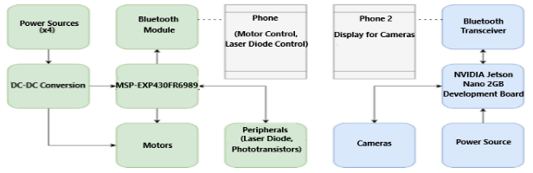
Fig 1. Overall system block diagram (Placeholder?)

System Components
Photo-TANKS contain various components that control different aspects of the device. As such, this section
contains a summary for all major components, from Fig 1 below, and what those components functions are.

Microcontroller
The first major component is the MSP-EXP430FR6989 microcontroller. The msp430FR6989 is a fairly inexpensive board coming in at roughly $24. This board consists of 18 physical pins that are GPIO enabled. This allows us to send and receive various signals from all of our components. This board also comes with 5 pwm pins for voltage variation as well as a built in 16 channel, 12 bit analog to digital converter. This Analog to Digital converter enabled pins is essential for our laser detection circuitry. The board was an easy choice for our application because it was cheap, has all of the functionality we require and is used widely throughout the academic field. The use of this device in the school environment means that we have previous experience using this board as well as the coding environment that is used with it. This decision significantly reduced our research and development time. The microcontroller will be the main control point for several aspects of the design. The
development board will be in charge of handling the operation of all of the servo motors, the reading of the signals from the phototransistors, to and from transmission through the wireless bluetooth transceiver, laser diode
control and control of the leds.
The second microcontroller that we will be using for our project is the Jetson Nano 2GB Development board. This board is made by Nvidia. The reasons that we chose this
board were its affordability as well as the graphical capabilities. The board comes in at roughly $264, however one of our members had a special pricing opportunity that
cut the cost down to 64$. The initial cost of this board was slightly higher than the competitors, however it comes with a memory capacity of 2Gb. The competing boards that would apply for our project only came in 1GB or
4GB+ packages. This meant that the other options were either under-capable graphically or too expensive due to having to pay for additional memory that was not needed.
The Jetson Nano 2GB comes with a built-in graphical processing unit that is required to handle the training and operation of our object detection system. More specifically, the graphical processing unit works in conjunction with the LPDDR4 SDRAM. These aspects of the device store and analyze images coming from the barrel camera and scan them in real time for shapes that we have pretrained the system to identify.

Servo Motors
The components in this section are servo motors. These servo motors control the movement of Photo-TANKS’ treads, barrel, and turret. Both the treads and turret have 360° movement, whereas the barrel has ±10° rise and fall.
This first motor we will discuss is a DC, Geared Brushless servo motor. This motor is responsible for the operation of the tank treads. The motor works in conjunction with a L298 Dual H-Bridge DC Stepper controller. The Dual H-Bridge motor controller is required to switch the polarity of the voltage supplied to the treads to reverse the direction of movement. The 25 geared brushless motor has a maximum operating voltage of 9V with a recommended operational voltage of 7.2V. This voltage will be supplied to each motor using AA batteries in series. These batteries will be fed through one of the voltage regulation circuits and then through the dual H bridge motor controller to operate the servo.
The second servo motor is the MG90D. This servo motor is a small and inexpensive servo motor. The motor consists of a plastic housing for overall weight reduction and cost reduction. The gearing of the motor is made of metal, this will increase overall operation time of the component. This motor operates at an ideal voltage of 4.8 volts. This will be supplied by 4 AA batteries in series. These batteries will then be fed into the power regulation circuit to reduce the voltage to the optimal value. The voltage is then fed into the dual H Bridge controller to control the polarity of the signal, allowing the turret to both rise and fall.
The last servo motor that is used is a 12V geared motor by Greartisan. This motor is responsible for the 360 horizontal movement of the turret. This motor follows a slightly different overall power supply ideology than the other motors listed. It will be powered by 6 AA batteries in series. This voltage will be fed into a power regulation circuit to reach the ideal operational voltage of 12V. This voltage will then be fed into a dual H Bridge controller to vary the polarity of the singal going to the servo motor.

Power Sources
The power sources for the design consists of two major categories. These categories are as follows. The first power source is a rechargeable power bank by Charmast.. This power bank has an overall capacity of 10000maH. The power bank is in charge of running the Jetson Nano Development board. It will supply 5v with a maximum current of 3A to the development board. The power is delivered through a USC-B connection directly from the power bank to the development board. The second power source category consists of various boost/buck power converters. These power converters are part of the PCB that was designed for the project. The various power conversion circuits are connected to multiple different AA battery holders which supply different voltages to the various conversion circuits. These power circuits then convert the voltages from the battery packs to the appropriate voltage and current levels of each desired function on the PCB.

Laser System
Next is the Laser system containing a L635P5 laser diode, a LA1039 plano-convex lens, and a TEPT5700 phototransistor. In Fig. 2 below, the laser system is set up.
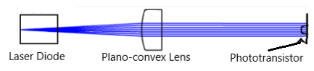
Fig 2. Conceptual Laser System

While the laser system may be simple, the laser diode and the lens will be in a set place, about 10 millimeters apart, to prevent optical loss, with the phototransistor(s) being anywhere from 50 millimeters to 10 meters away, as per reference to Section III. This system will essentially detect whether or not the device connected to the phototransistor is an enemy or not, by a unique identification code mentioned in Section II.
The L635P5 laser diode is a low powered, class 3R laser diode. Due to the low power, it does not need much voltage or current input to produce a noticeable laser point. This diode has a low minimum divergence of 6° up to a max divergence of 10°, which will be fine for the 10 meter engineering specification mentioned in Section III.
The next part is the LA1039 plano-convex lens, due to its small focal length of 9 millimeters, and when the laser diode is close enough to the lens, we can prevent a significant divergence of light.
And the last part of this system is the TEPT5700 phototransistors. For Photo-TANKS, we wanted to have a high responsivity, so that we could easily tell if a light source, more specifically from the L635P5 laser diode, is hitting against the phototransistor.

Cameras
The next component that we will discuss is the camera. More specifically, we will be discussing the barrel camera. This camera is responsible for the capturing of video that will then be fed into the jetson nano. The Jetson Nano will then analyze these images and identify the pre-trained objects that we have defined. The camera that we have chosen is the IX219-70. This camera is manufactured by Waveshare and is designed to be directly compatible with the Jetson Nano. The camera sports a 8 Megapixel resolution and uses the Sony IMX219 as the core sensor. The camera supports a maximum resolution of 3280 x 2464. Due to processing limitations, we are only using a resolution of 1080P. This is because, when we use a larger resolution, the Jetson Nano has too much latency during the processing of images.

System Design
Since Photo-TANKS is a combination of pre-made structures and currently made structures, this section is about any hardware that was produced specifically for Photo-TANKS.

Exterior Design
The exterior of Photo-TANKS is a metallic casing that will hold most of the internal components mentioned in Section VI. Its body design is a slightly derived, box-like tank, as shown in Fig. 3, with several 5mm holes along the sides for phototransistors and wires to connect the batteries.
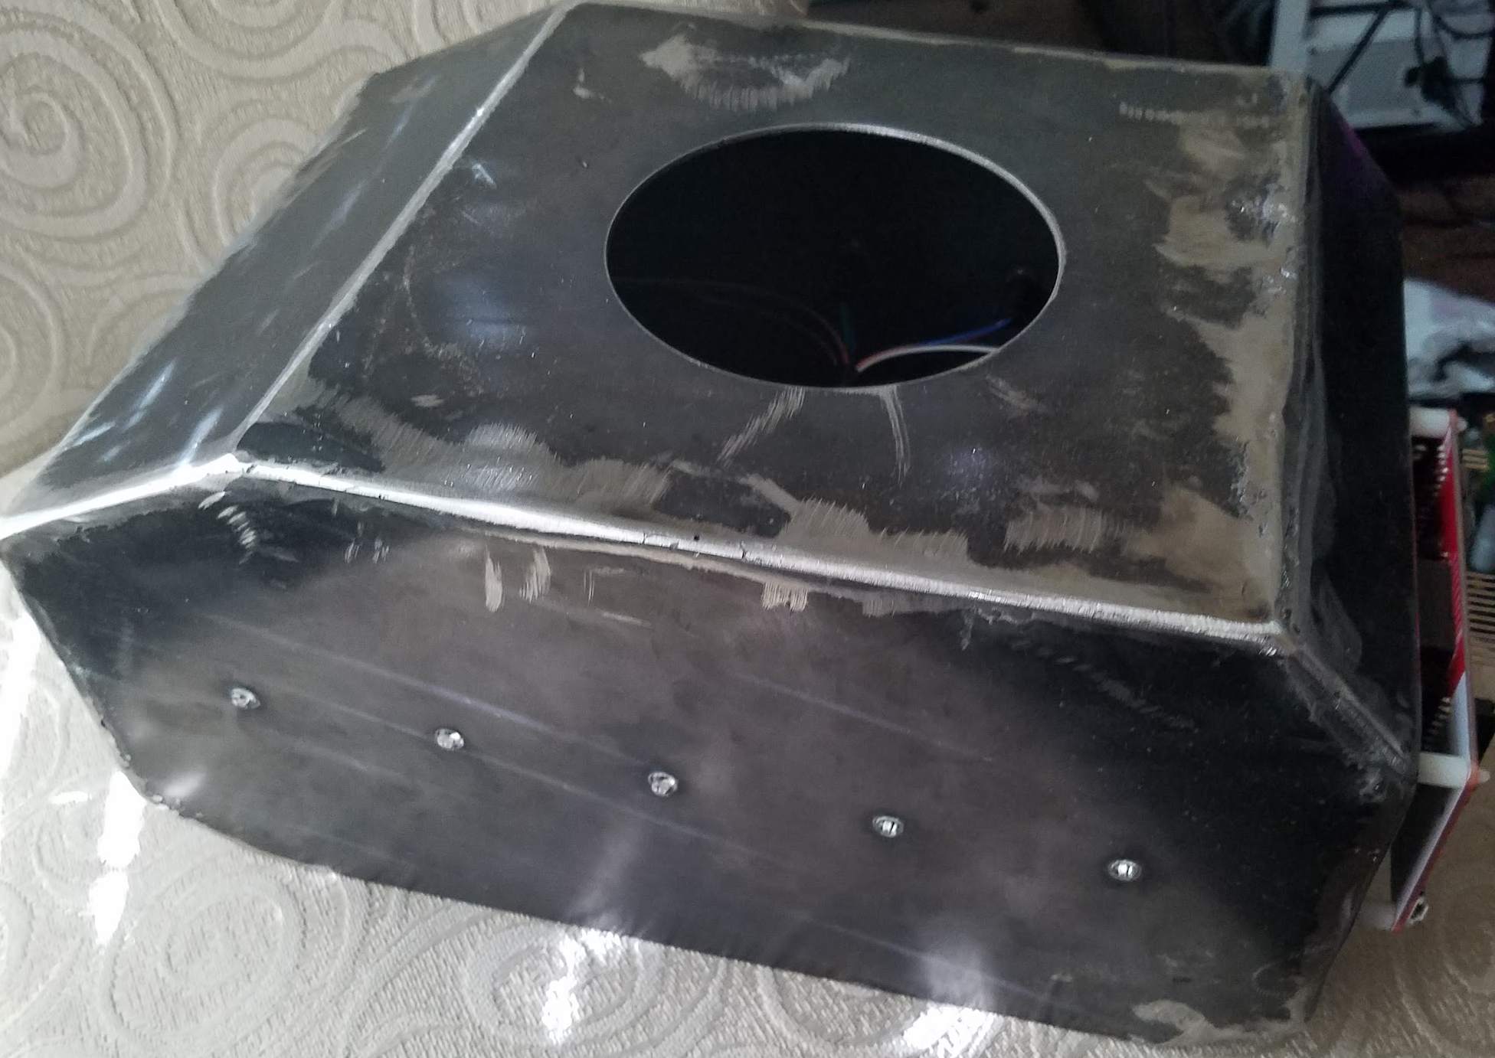
Fig 3. Metallic casing of the body

Also, the turret design is similar to a box-like turret, as shown in Fig. 4. The turret will also have various holes along the sides for phototransistors and wires for connections, and an area to connect the barrel containing the laser system.
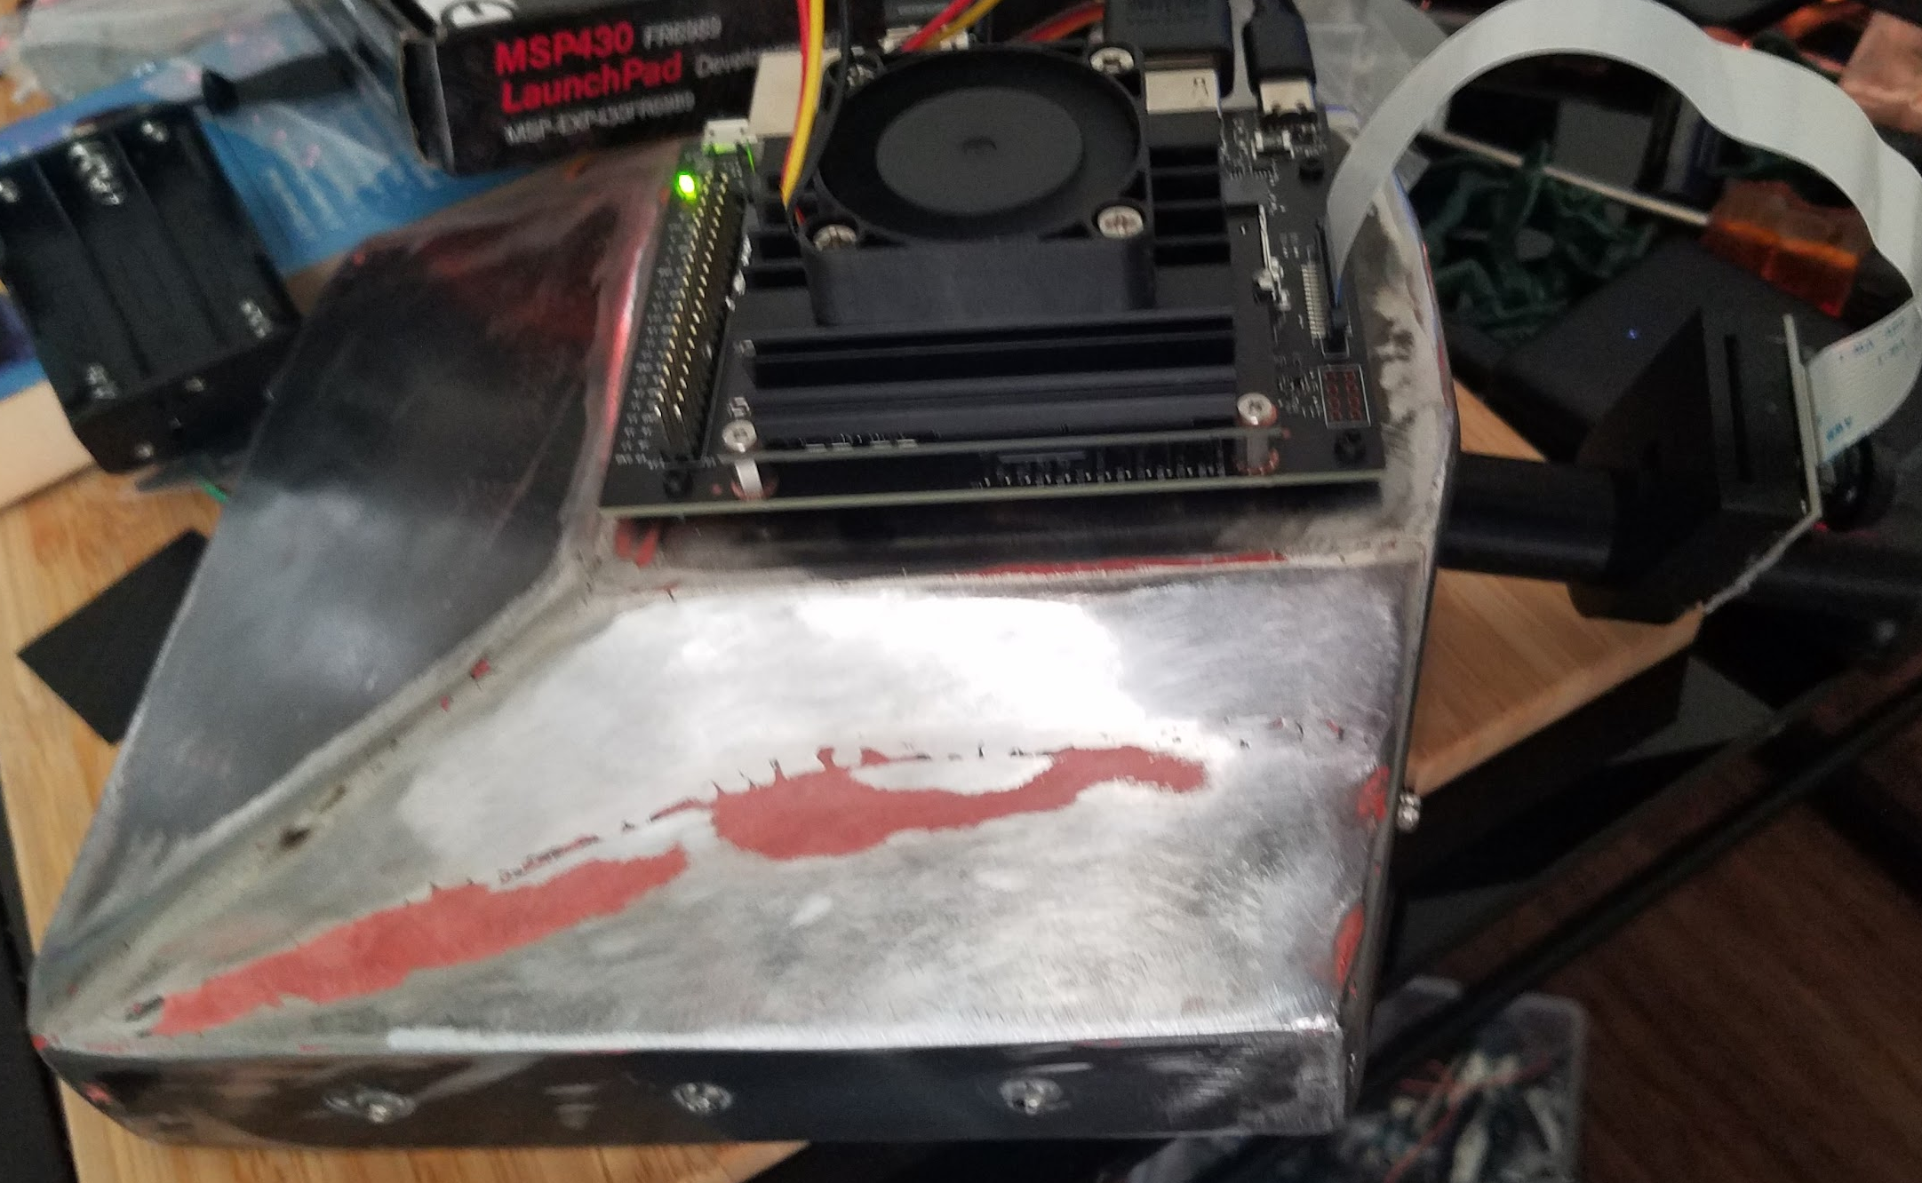
Fig 4. Metallic casing of the turret plus barrel

The next main exterior designed part is the barrel, which is holding the laser diode, the lens, and the camera. While the laser diode and lens cannot be seen, the camera is noticeably attached to the barrel as seen in Fig. 4.
The last main exterior designed part is the connector for the body and turret. It is connected to a gear that will rotate the turret with a motor connected to it, as shown in Fig 5. This part will let the wires connected to the turret section down to the body section.
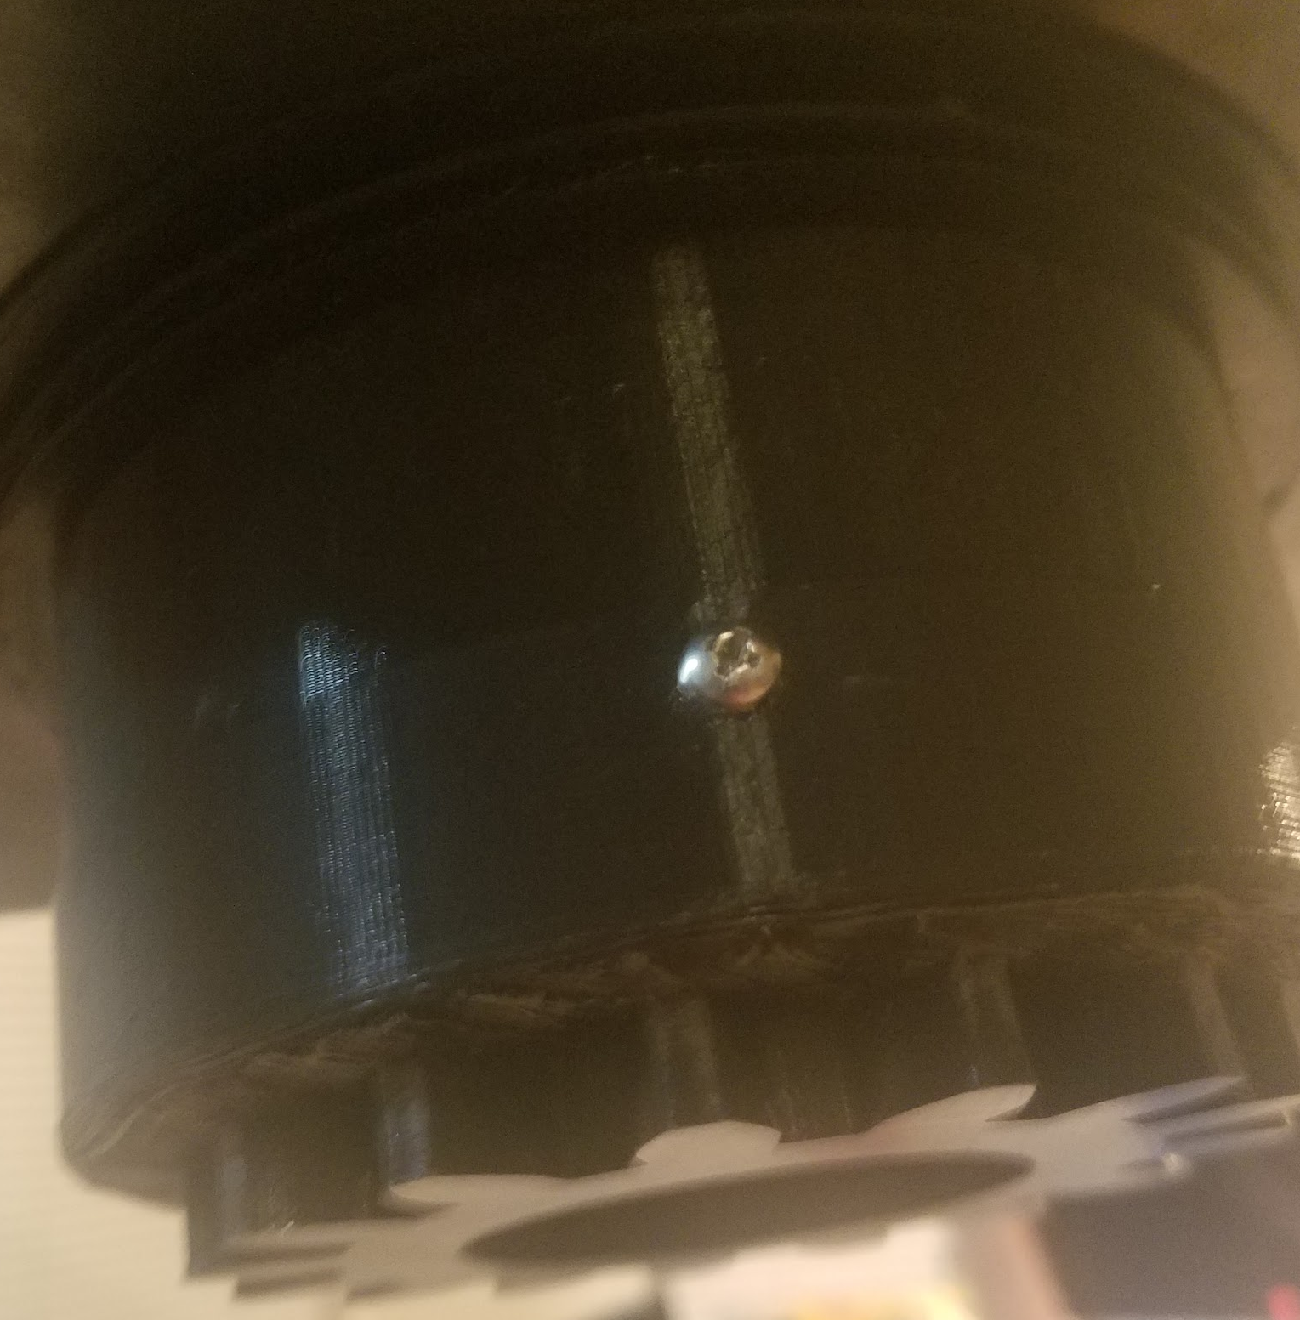
Fig 5. 3D print of the connector without motor

Mounting
Since, the interior of Photo-TANKS has a limited amount of space, and since we do not want to have some components floating, we have designed some risers and platforms to hold some internal components and external components. These platforms will be designed to hold the PCB and microcontrollers, using their dimensions. Whereas the risers come in different sizes, like 7 millimeters, 10 millimeters and 20 millimeters as shown in Fig. 6.
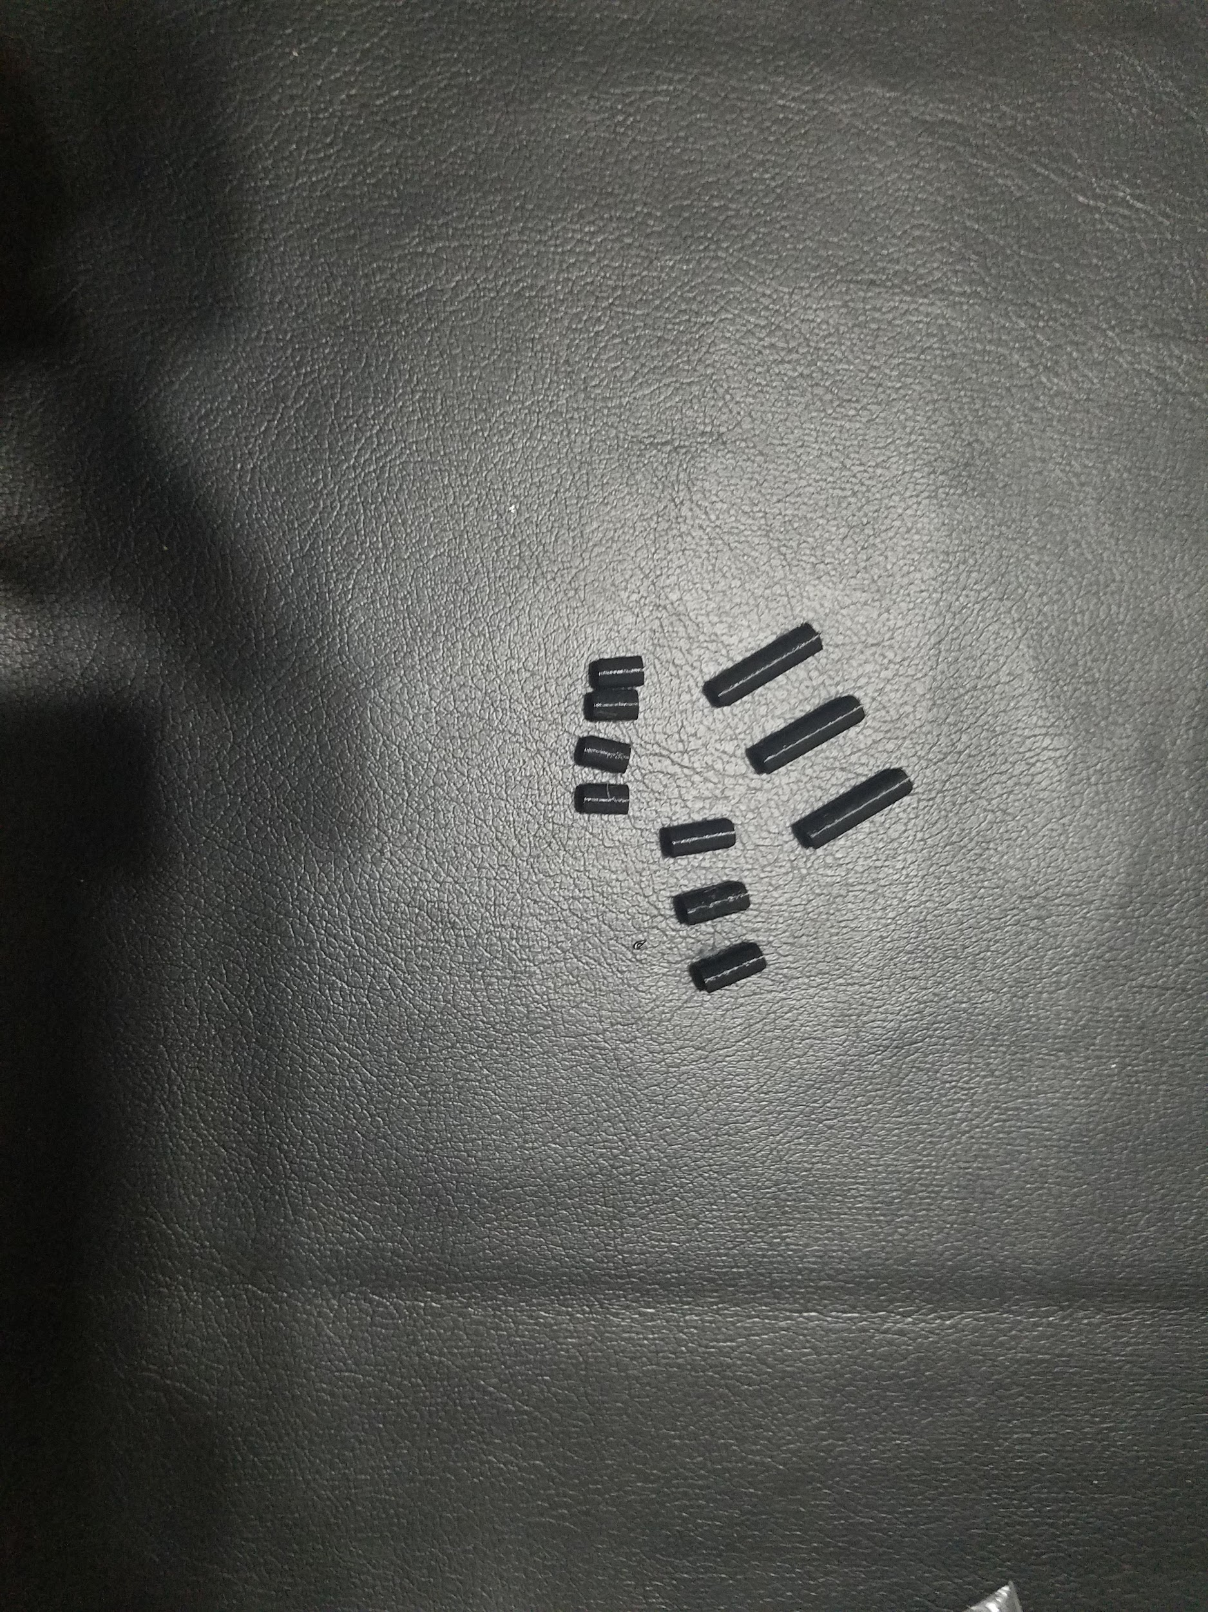
Fig 5. Risers of different sizes

Using these risers/platforms will make most of these parts more easily replaceable, if a part needs to be changed or adjusted.

PCB Design
The PCB design started with designing any and all schematics that would be needed for Photo-TANKS and combining them into one whole system. When developing this PCB to have it integrate and control all the electronics on board, we will need to use voltage regulators to hold and maintain a constant 5 voltage across each motor, phototransistor, and laser diode for constant function. The overall design of the PCB can be seen in Fig. 6.
The first major circuit we used was a circuit for the DC/DC converter to connect the INIU power pack with a set of batteries for backup to the Jetson Nano. So the Jetson Nano could still run if the INIU power pack is out of charge by the batteries. Since the Jetson Nano requires 4.25 V, to maintain power, and since the recommended input current of its power supply is 3 A, we figured that using both in conjunction would keep the Jetson Nano online.
The next major circuit would be the motor circuits. These circuits would just be connecting the motors, both the servo ones and the brushless geared one to a set of batteries and the msp430FR6989. Each is connected to a set of batteries, of different amounts, but 4 or 5 batteries each will be able to do the trick.
The next, and last, major circuit is the phototransistor circuits. These circuits connect each phototransistor to the PCB and the msp430FR6989. When connected, the PCB will send information, by voltage and current, to the msp430FR6989 so that it can register the “hits” and “misses” from a light source.
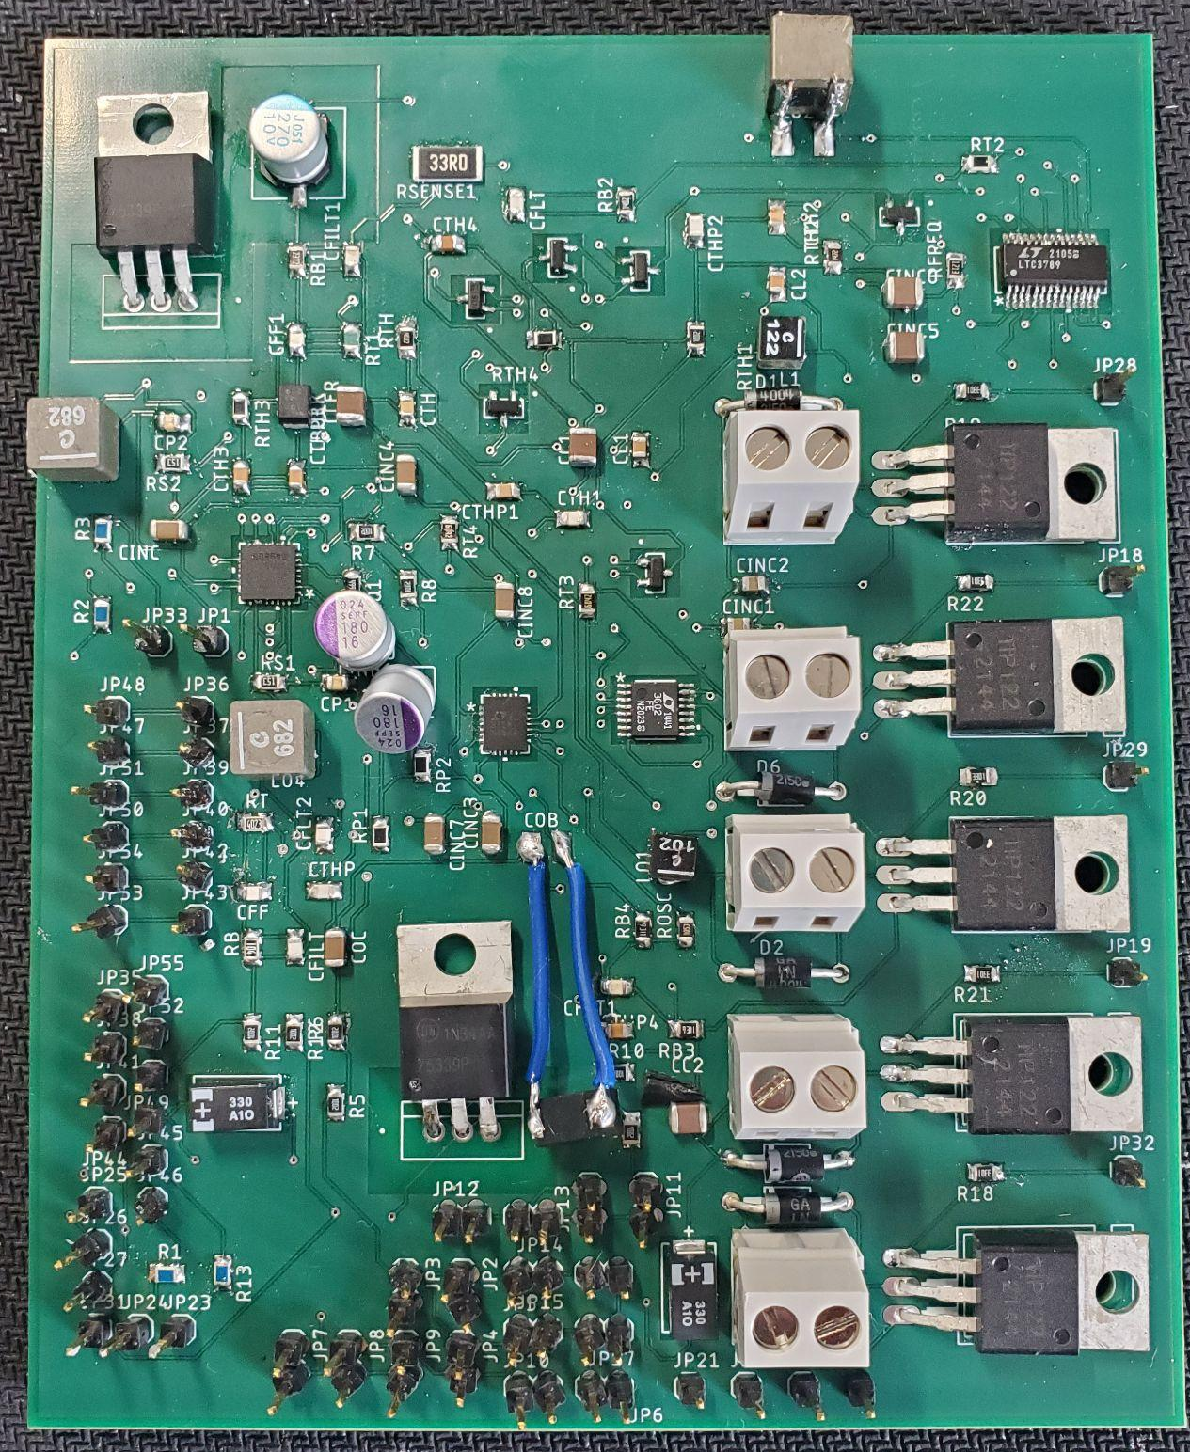
Fig 6. PCB design

Software Design
In this section, we will talk about the software designed for Photo-TANKS. For both the Jetson Nano and the msp430FR6989 we have chosen Python to write up the programs. These two microcontrollers are the most critical components for Photo-TANKS, since as mentioned previously in Section IV, the Jetson Nano will be handling the training for our object detection system and the msp430FR6989 will be controlling the motors and the laser diode, plus monitoring the signals from the phototransistors and the transmission from the bluetooth transceiver. Without these, more for the msp430FR6989, Photo-TANKS would not function and would essentially be a paperweight.
When coding the Jetson Nano, we essentially want the program to do this:
- Start up, with either a wired connection or wireless connection
- Get camera feed by streaming with gstreamer
- Connect to the VLC plugin, and search for the stream
- Display the stream over a local network
- Await for a successful connection
- And, once connected, standby for user input
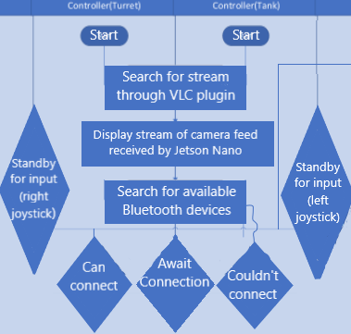
Fig 7. Program flowchart for the controller

Whereas, we want to code the msp430FR6989 to do this:
- Startup
- Attempt to connect to: the motors, phototransistors, laser diode, power sources via DC/DC converter, and the bluetooth module.
  - If any component does not connect, then it will attempt to reconnect.
  - If the component does connect then proceed to standby for user input.

Challenges, Integration, and Testing
So, in this section, we will go over any challenges and problems we had, our solutions to them and then go into integration and testing after that.

Challenges
When designing Photo-TANKS, we ran into some problems, and had to work around them. Firstly, due to continuous testing of the PCB, we have short-circuited it. Due to an error in translation of buying and receiving the PCB, the ground-line was missing. At first, using the PCB was okay, due to it not being connected to any of the phototransistors, but once we connected all 11(?) phototransistors, the phototransistors produced too much additional voltage and current from the ambient light, it short-circuited the PCB. To circumvent this, we swapped to using a breadboard with various resistors to connect each battery mount, motor, laser diode, and microcontroller.
Another problem that occurred was attempting to add too much to do. For example we attempted to have three cameras on top of Photo-TANKS and a camera on or near the chassis. This would have meant that Photo-TANKS would have had 5 cameras, each with its own feed, connecting to the Jetson Nano. It might have been fine, if we had more RAM, but sadly, 2 GB does not have enough memory for 4 more cameras. So, because of that, we had to only use 1 camera, to at least have some sort of object identifier.
The last major challenge we had was actually trying to integrate everything together. Since, when we had to change or edit a part, we would have to detach the treads, play around the amount of wires, and either adjust the connections or parts of the body. But, when there was a problem with a part in the turret, instead of adjusting the parts of the body, we would have to disconnect the connector and then adjust a part. Then afterwards, we would have to connect everything again. There was not really a way to circumvent this, so we just attempted to get everything right and connected the first go for Photo-TANKS.

Integration
Once we got over all the challenges we had, we used all the components in Section IV to finally complete Photo-TANKS. To label them out again, we used: two microcontrollers, the msp430FR6989 and the Jetson Nano, three motors, the 25 geared brushless motor, the MG90D and the DF15RSMG, the INIU power pack and several AA batteries, the L635P5 laser diode, several TEPT5700 phototransistors, the LA1039 plano-convex lens and the Ix219-70 camera. Also, the PCB, and a breadboard with connected wires and resistors for the work around of the PCB. Plus, the metallic shell for the body, turret and the plastic casing of the barrel plus all the risers/platforms we made. And, other minor parts like the tank treads.
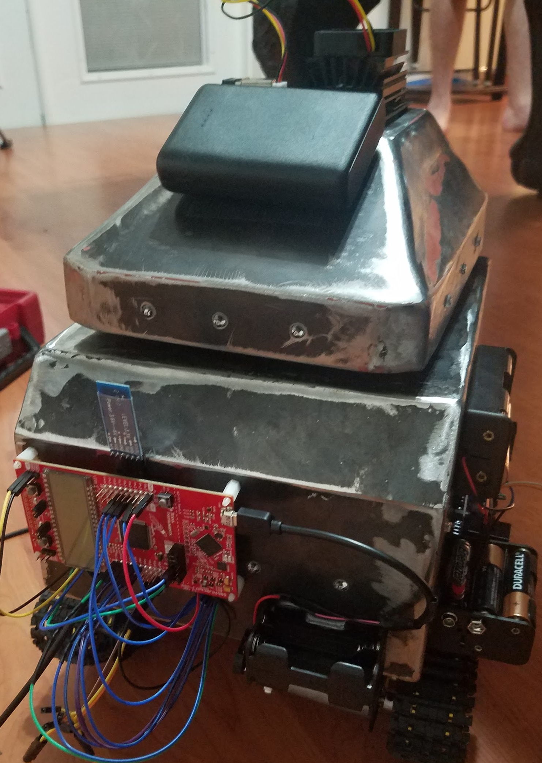
Fig 8. Photo-TANKS completed, back side

Testing
When testing Photo-TANKS, not only were we trying to achieve the engineering specifications we selected, but also some more selected ideas. Like, having the turret rotate 360° and having the treads climb up to a certain height. So, firstly we will go over our chosen specifications to show off, and then go over our own specifications for some more information.
Before any of the testing could begin, we had to check to software of Photo-TANKS to make sure that the following occurs:
- Ensure that the msp430FR6989 and the Jetson Nano are connected correctly and have power.
- Run the code for each motor and make sure each moves and adjust accordingly.
- Make sure that the phototransistors do not mess up any other circuitry.
Once all of this is verified, or mostly verified, then we could attempt to test our specifications.
To start off, our first specification was having the image delay of Photo-TANKS being less than 0.1 seconds. This works in that Photo-TANKS can scan an area in either less or about 0.1 second, but the object acquisition is a little off when using it. Most of the time, it can detect that there is something detected, but what it detects can be slightly similar or something way off.
Our second specification was having the beam waist go up to 10 meters. Using the laser-lens system, we were able to go 10 meters, and probably farther. But, due to size limitations of the house, we could not reliability test any farther than 10 meters.
And, our third specification was to have the turret responsiveness be less than 1 second. Based on the optimized code, we can get the turret to rotate and the barrel to rise/fall quite fast after inputting directions for Photo-TANKS on a created controller that moves the treads, turret and barrel by joysticks.
Then, for more personal specifications, while we could get the turret to move, the gear that was connected to one of the dc brushless motors was not connected fully, so it was able to move the gear briefly, but then stop it afterwards.
The next personal specification was to see how high the treads could climb, we found out that the treads could climb up to 3 millimeters and anywhere above it would either cause the tank to fall backwards due to Photo-TANKS being back-heavy or just not being able to climb it at all, where Photo-TANKS would just be attempting to move the item.

Conclusion
Blossoming from the idea of tank laser tag, to growing into a proof of concept design for target identification and acquisition for real world military application, Photo-TANKS has gone through quite a journey. And the path it took along that evolution seemed to come quite naturally and fluidly. From the beginning our team had an equal amount of excitement for the project and inspiration to turn it into something greater was rather trouble-free. Due to expensive and difficult to get parts, our team knew that we would not exactly be able to develop an entire system that could be used for the military given our time and budget constraints, we had the desire to design and build something that could prove to be of use.
Even though Photo-TANKS evolution came fairly naturally, there were still a handful of challenges our team had to overcome. Originally, we were a little overambitious with our aspirations. It was rather easy to be, because while we were conducting research it felt like every time we turned over a new stone we would find new inspiration for another feature for our project. Overtime though we honed in on our core goals and objectives and really gained some traction. Making sure every component was compatible with one another was the next big challenge. While some of the hardware was not too difficult to make sure of, such as matching the spectral responsivity of our phototransistors with our laser diode, other components were not as simple. Since our team plans on using the Jetson Nano AI Kit for the brains of our artificial intelligence, we had to make sure that anything connected with that would work. This really limited our market of parts available and sometimes we had to make sacrifices because the better part was just too expensive. The largest challenge our team had to overcome showed up when we discovered the difficulties of using a singular 360° camera for our target acquisition system. Limited by cameras available that were compatible with the Jetson Nano, the ones available on the market were extremely expensive. Essentially, our team had to go back to the drawing board and completely redesign that system. A task that turned out to be far more challenging said than done. The solution of using multiple cameras was clear, but how was the question. No one on our team was familiar with how video stitching worked or how it could be done.
At the end of the day, our team selected this project because we wanted to challenge ourselves and put the skills we have been learning in our respective disciplines to the test. Each one of us wants to prove our knowledge, but most importantly each one of us wants to design and build a project that we are proud of. Photo-TANKS is just that.

Acknowledgement
We would like to acknowledge the University of Central Florida, most of their professors and more loved ones for their assistance and support throughout the creation and production of this project.

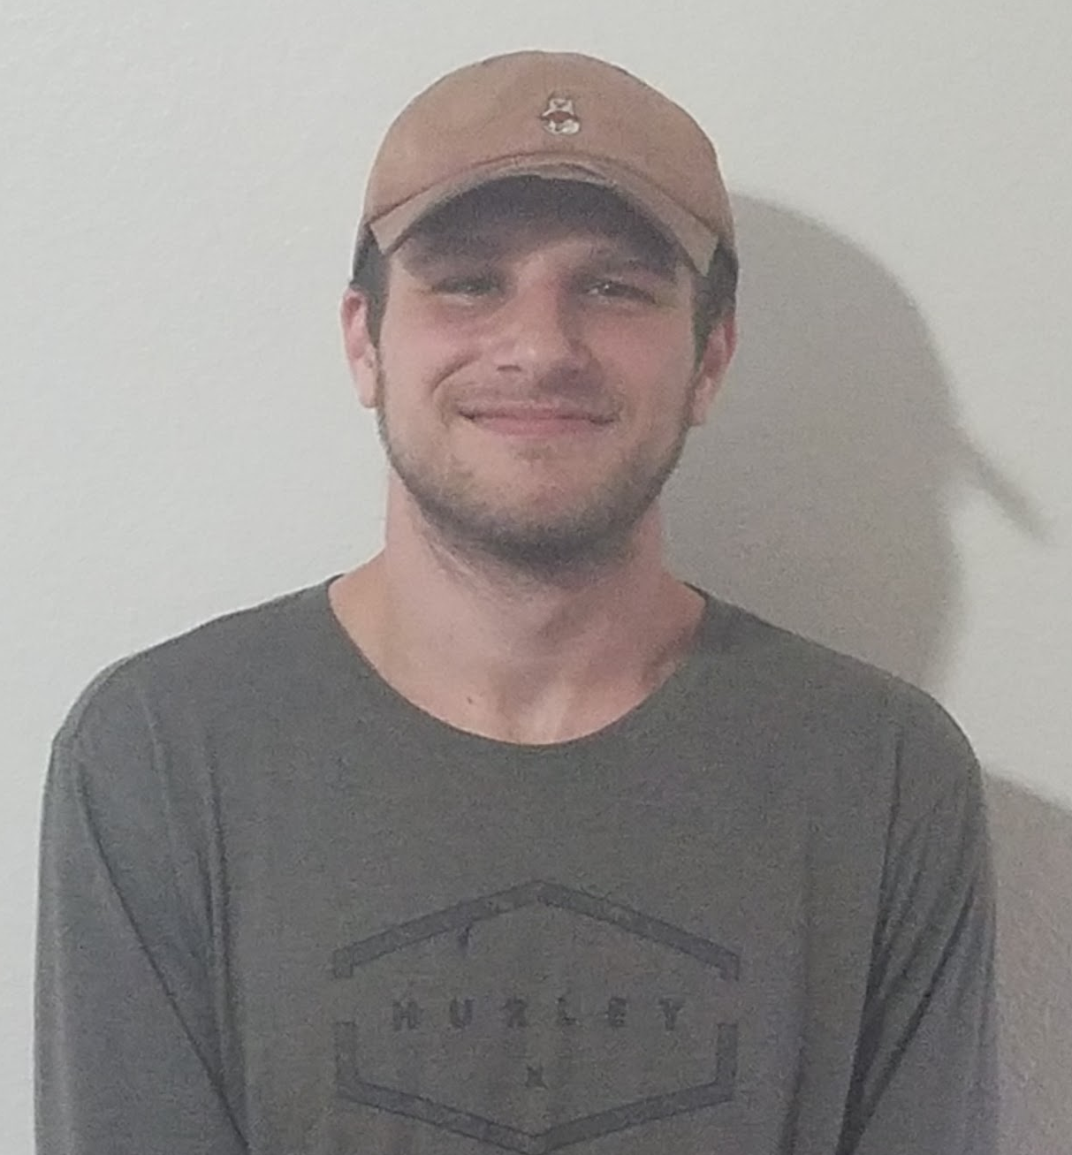
Author Biography
Dylan Perkowski is a senior at the University of Central Florida, studying and receiving his Bachelor's degree for Photonic Sciences & Engineering in May 2022. He intends to continue his studying by going to grad school after he gets his Bachelor’s degree.
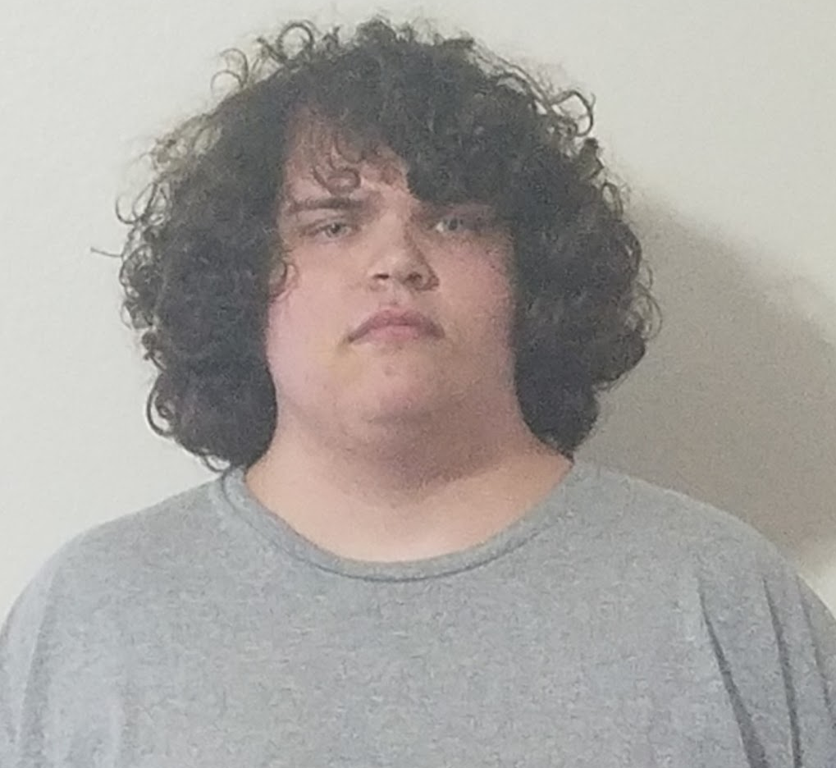
Joshua Walton is a senior at the University of Central Florida, studying and receiving his Bachelor’s degree for Photonic Sciences & Engineering in May 2022. He intends to pursue a career in his major once he receives his Bachelor’s degree.
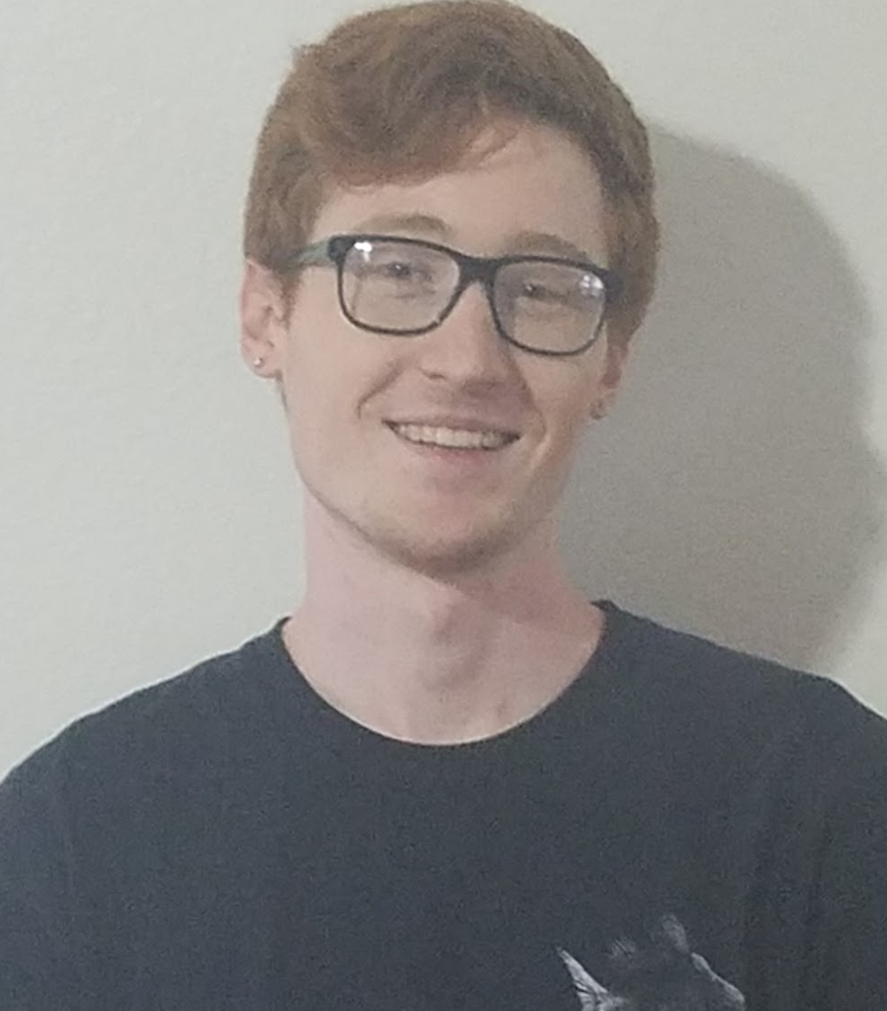
Skyler Burns is a senior at the University of Central Florida, studying and receiving his Bachelor’s degree for Electrical Engineering in May 2022. He intends to continue working for L3 Harris after receiving his Bachelor’s Degree.

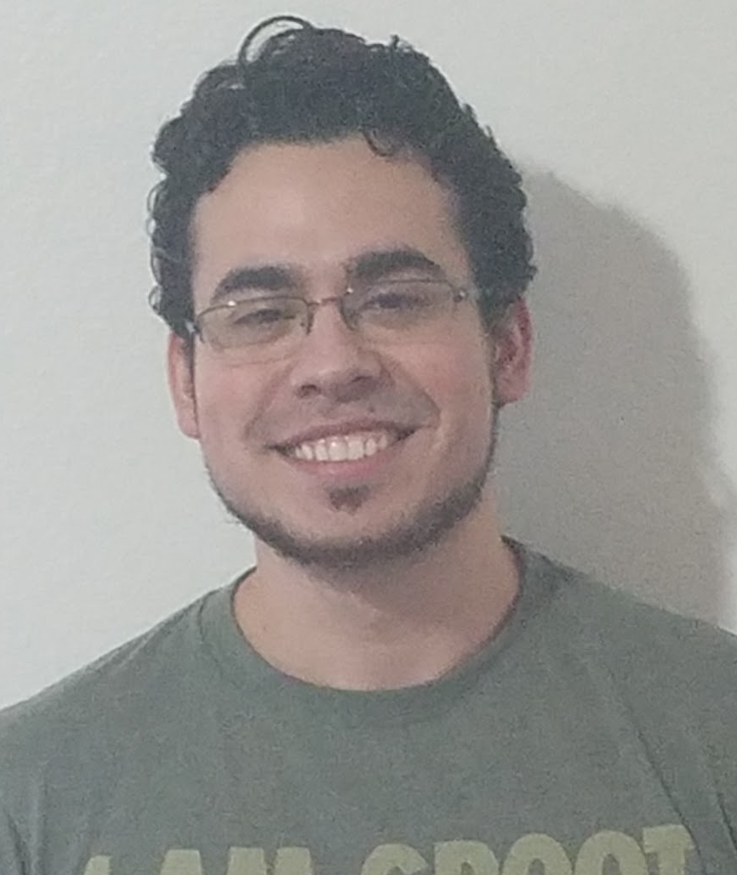
Joshua Frazer is a senior at the University of Central Florida, studying and receiving his Bachelor’s Degree for Computer Science in May 2022. He intends to continue working for his current job after receiving his Bachelor’s degree.

References
[1] Pike, J, FM 17-12-8 Chapter 3 Target Acquisition, Globalsecurity.org, https://www.globalsecurity.org/military/library/policy/army/fm/17-12-8/ch3.htm

